Client / Department | Prestige PEO / Benefits Administration
Process Name | Benefit One Pager
Process ID
Procedure Description | Benefit One Pager
Primary Responsibility | Process Manager
Triggered By | Emails
Software / Application Used | Prism, Abode Acrobat, Outlook, Carrier Portals

Prepared By | Approved By | Version Number
Keerthika Kannan | Ramesh B | 1.0

Circulation List
S. No | Name | Designation | Email Address
1 | Jeff Deloach | President | jeffd@cognethro.com
2 | Sampath Kumar | Vice President Operations | sampathk@cognethro.com
Process:
S. No | Name | Designation | Email Address
1 | Ramesh B | Manager | rameshb@cognethro.com

INDEX

S. No | Description | Page No.
1 | Applications/Systems, Access levels & Input Document Required | 3
2 | Procedure Overview | 3
3 | Processing Time | 3
4 | Service Level Agreement | 3
5 | Procedure Map | 4
6 | Procedure with Screen Shots  Open the Benefits One Pager Template  Review Client Benefit Plans  Review Active Benefit Plans  Verify Benefit Rules  Update Waiting Period  Customize Benefit Plans  Review FSA and Life Benefits  Review Additional Benefits  Format the Benefits Overview | 5  6  7  10  12  14  15  19  23  24
7 | Frequently Asked Questions (FAQs) | 27
8 | Appendix | 28
9 | Process Updates | 29

1. Applications/Systems, Access levels & Input Document Required

1.1 Applications/Systems Required, Access Levels
S. No | Description | Access Levels
1. | RDC | User
2. | Prism | Advanced
3. | Adobe acrobat | Advanced
4. | CogNet Benefits – Prestige PEO Email Inbox | User

1.2 Input Documents Required
S. No | Document | Access Level
1. | SBC Document | User
2. | Process Instructions | User

2. Procedure Overview:
The Benefit One-Pager Process involves creating a concise, client-specific benefits summary document that highlights the organization's active employee benefit offerings. The One-Pager serves as a quick reference guide for employees during onboarding and open enrollment and is derived from information maintained within PRISM, carrier documentation, and the Benefits Guide.

3. Processing Time:
S. No | Date | Reason | Approved By | Total Time
1. | 08/03/2026 | - | Ramesh B | 30 Mins

4.Service Level Agreement:
Service Component | Turnaround Time | Accuracy

5. Procedure Map
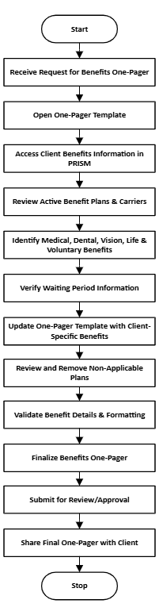

6. Procedure with Screen Shots:

Open the Benefits One Pager Template
Step 1: Open the Benefits One Pager Template.
Verifying Carrier Information on the Benefits One Pager Template
• The PowerPoint: Carrier and plan details for the client will be listed here.
• The Benefits Guide: Also contains the carrier information needed to complete the template accurately.
• Additional Sources: Verify the information from other available sources and ensure the correct carrier is referenced before finalizing the One Pager.
Note: Always verify the carrier before populating the template to ensure the client receives accurate benefits information.
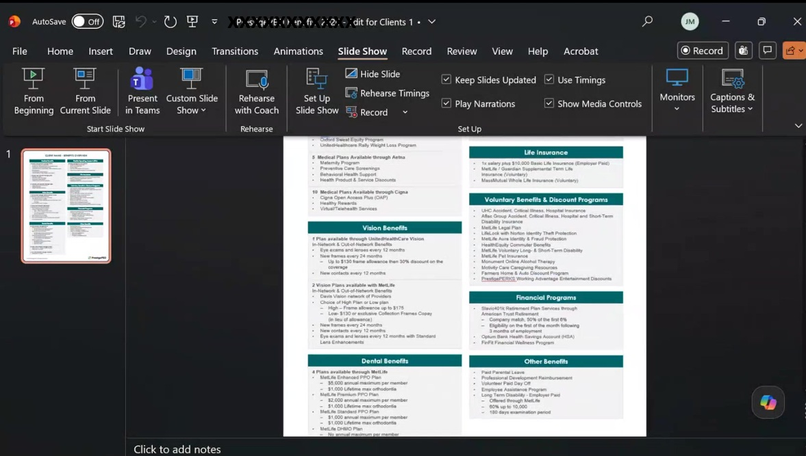
Figure 1 Power Point Document

Review Client Benefit Plans
Step 2: Navigate in Prism. Verify client name.
Go to Client Benefits Overview in Prism.
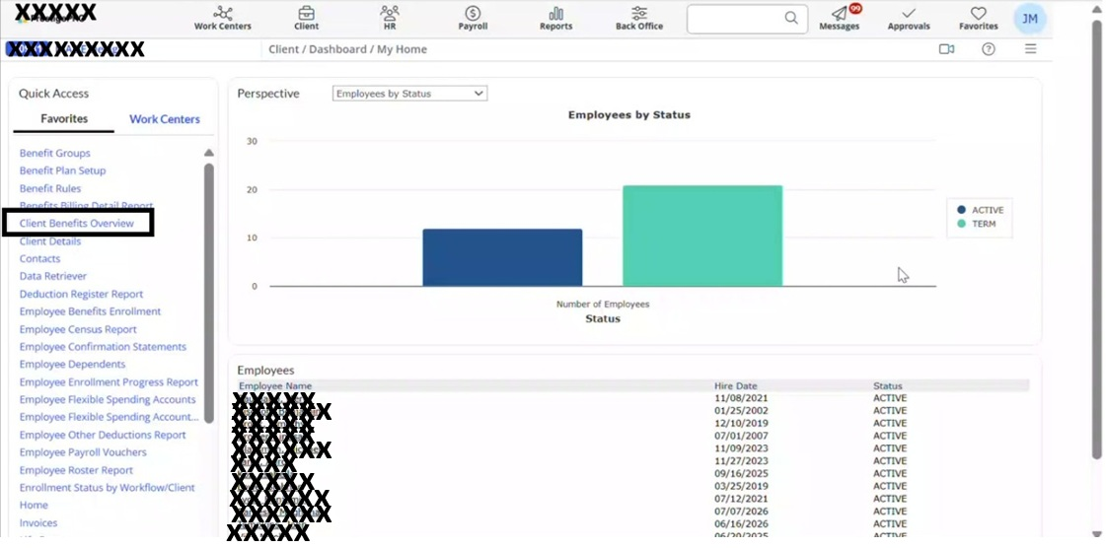
Figure 2 Go to Client Benefits Overview

Step 3: Execute the report to generate the benefits data.
Duplicate plan entries are expected to reflect different class setups and domestic partner coverage.
Plans with no end date are currently active and available to client employees.
Start by locating the medical plans section first when reviewing the report.
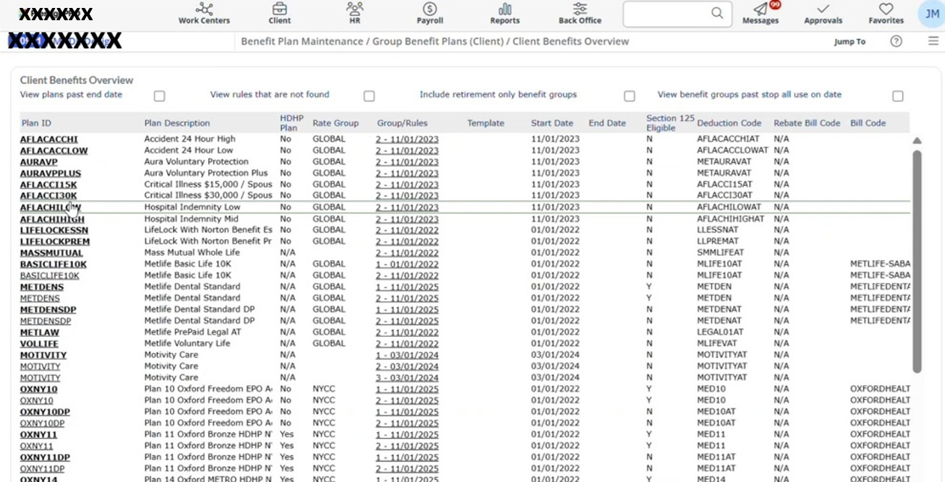
Figure 3 Client Benefits Overview

Step 4: Convert the report to PDF or download it to Excel to expand columns and view full plan descriptions more easily.
Medical Plans: The description column identifies the plan type; for example, all Oxford plans will be labeled accordingly.
Duplicate Entries: This is normal duplicates appearing because of different class setups and because domestic partners receive their own separate line item.
Active vs. Inactive Plans: If a plan has no end date, it is currently active and being offered to that client's employees.
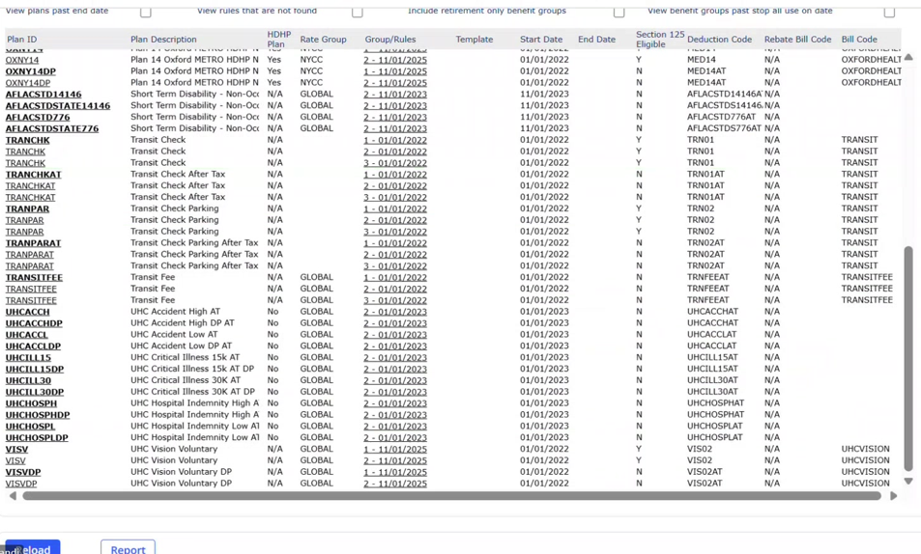
Figure 4 Plan Details
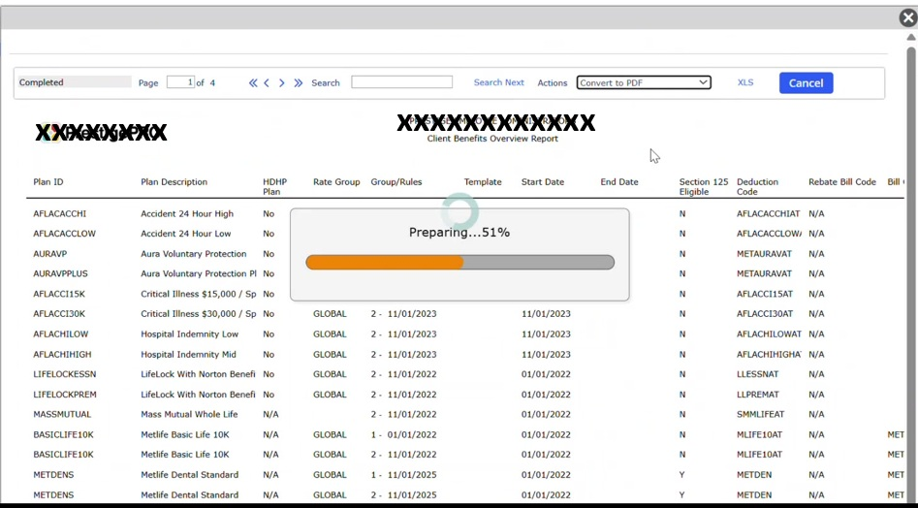
Figure 5 Convert to PDF

Review Active Benefit Plans
Step 5: Run the Client Benefits Overview Report.
This report shows every benefit plan currently active for the client. Use it to confirm which plans and carriers are in scope.
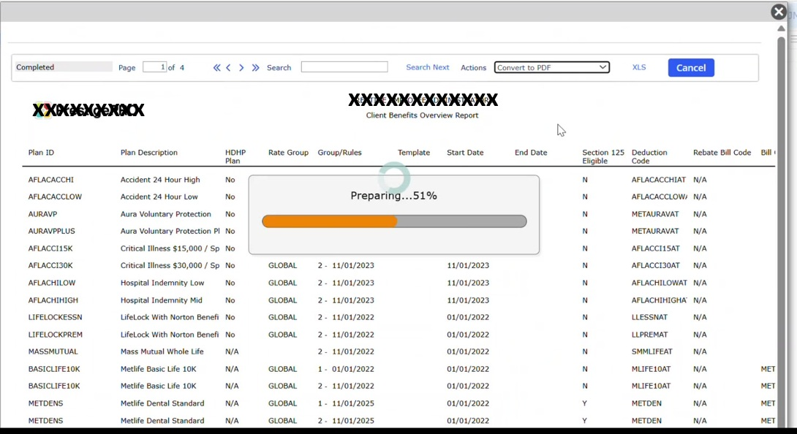
Figure 6 Client Benefits Overview Report

Step 6: Identify the active carrier, in this example, medical plans are available through Oxford. Only Oxford-relevant content is kept.
Delete any rows or sections tied to carriers not applicable to this client such as UnitedHealthcare (Freedom and Liberty plans), Aetna, and Cigna in the PowerPoint one document.
Keep language general. For example, always use phrasing like "generous employer contribution" regardless of the actual contribution level, since this summary supports client recruiting efforts.
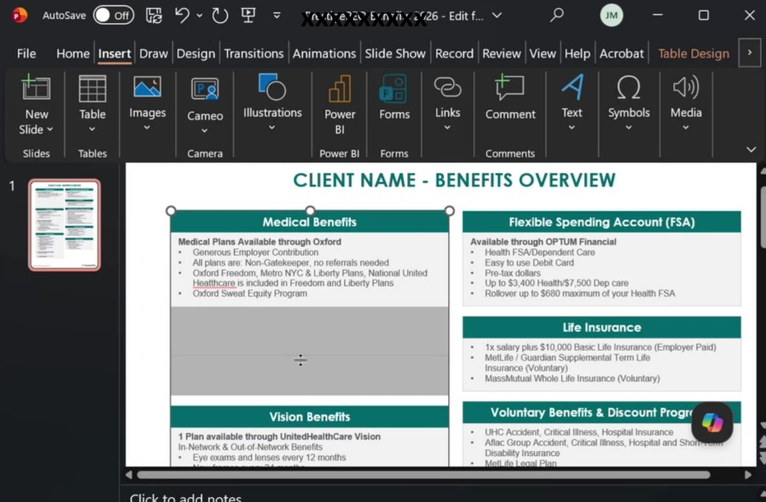
Figure 7 Delete rows that are not applicable

Verify Benefit Rules
Step 7: Navigate to Benefit Rules in Prism.
Note: Client Name: Always enter the client's name exactly as it appears in Prism — all caps. For example: MADE Design.
Include the benefit year in the title. For the upcoming open enrollment, the title should read: 2026 Benefits Overview.
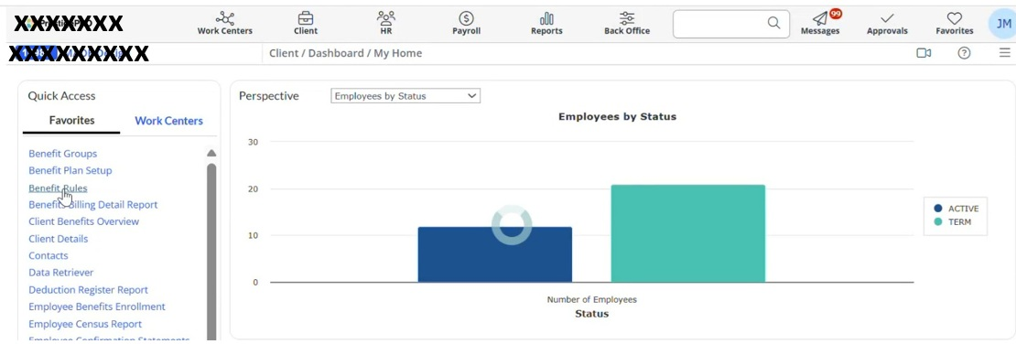
Figure 8 Navigate to Benefit Rules

Step 8: Select the general employee class in Benefit Group drop down.
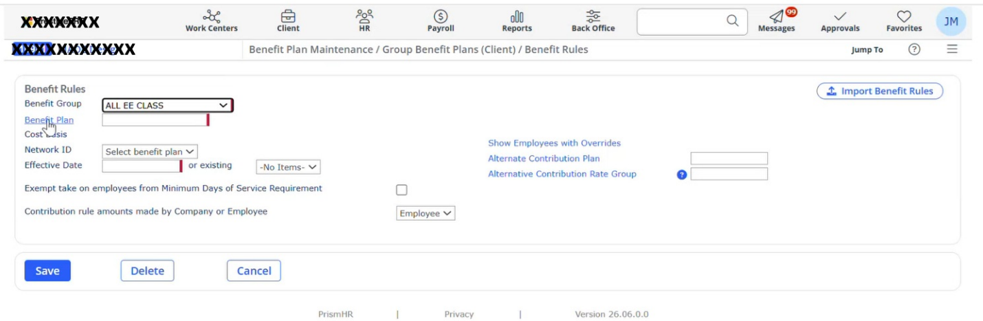
Figure 9 Select Benefit Group

Step 9: Select benefit medical plan.
Use the medical benefit to determine the waiting period, as it provides the most accurate indicator.
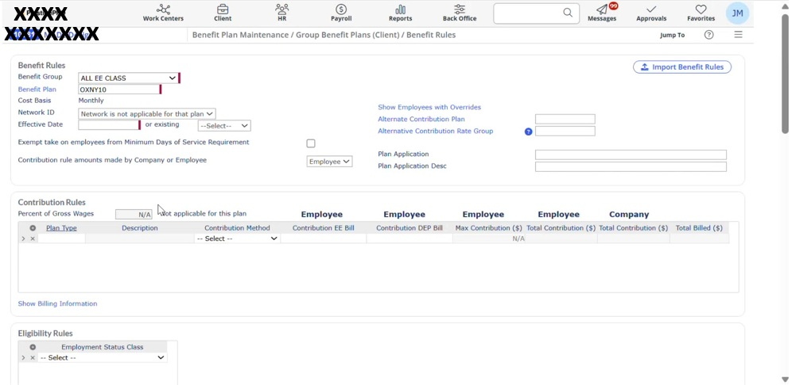
Figure 10 Select benefit medical plan

Update Waiting Period
Step 10: Note the waiting period number displayed (e.g., 60 days).
Enter the identified waiting period at the bottom of the Benefits Overview one-pager.
• 0 days: 1st of the month following the date of hire.
• 30 days: 1st of the month following 30 days.
• 60 days: 1st of the month following 60 days.
Note: The period a new employee must wait before benefits become effective, typically beginning on the 1st of the month following a specified number of days.
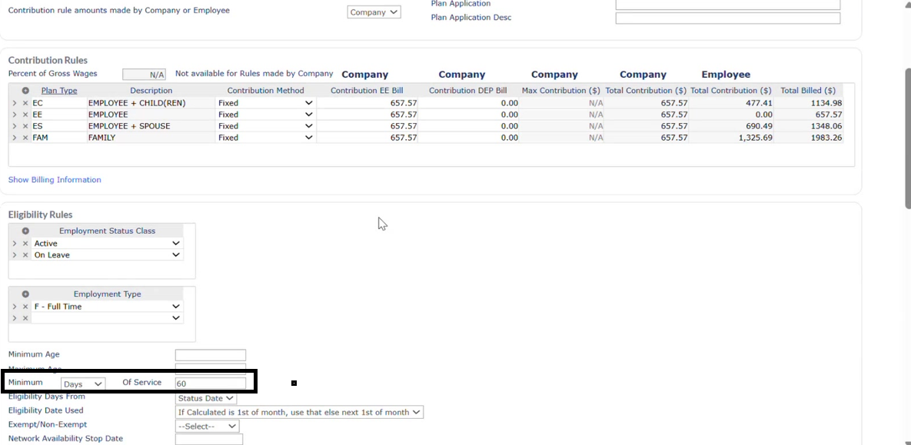
Figure 11 Minimum Days

Customize Benefit Plans
Step 11: Select All employees’ class.
Always customize the benefit summary, the default includes all options, not just the client's selections.
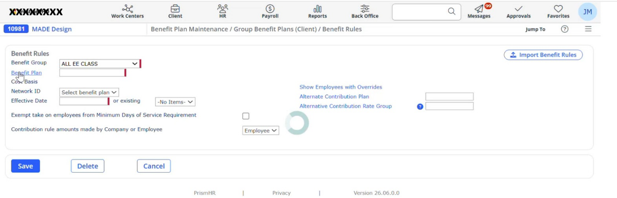
Figure 12 Select All employees’ class

Step 12: Verify all the benefits plans that are offered.
Confirm whether the client uses UnitedHealthcare Vision or MetLife Davis Vision, not both.
If the client has UnitedHealthcare Vision only, remove all MetLife Vision entries.
If the client has MetLife Davis Vision, remove the UnitedHealthcare entry.
A vision carrier that offers two plan tiers a high plan and a low plan.

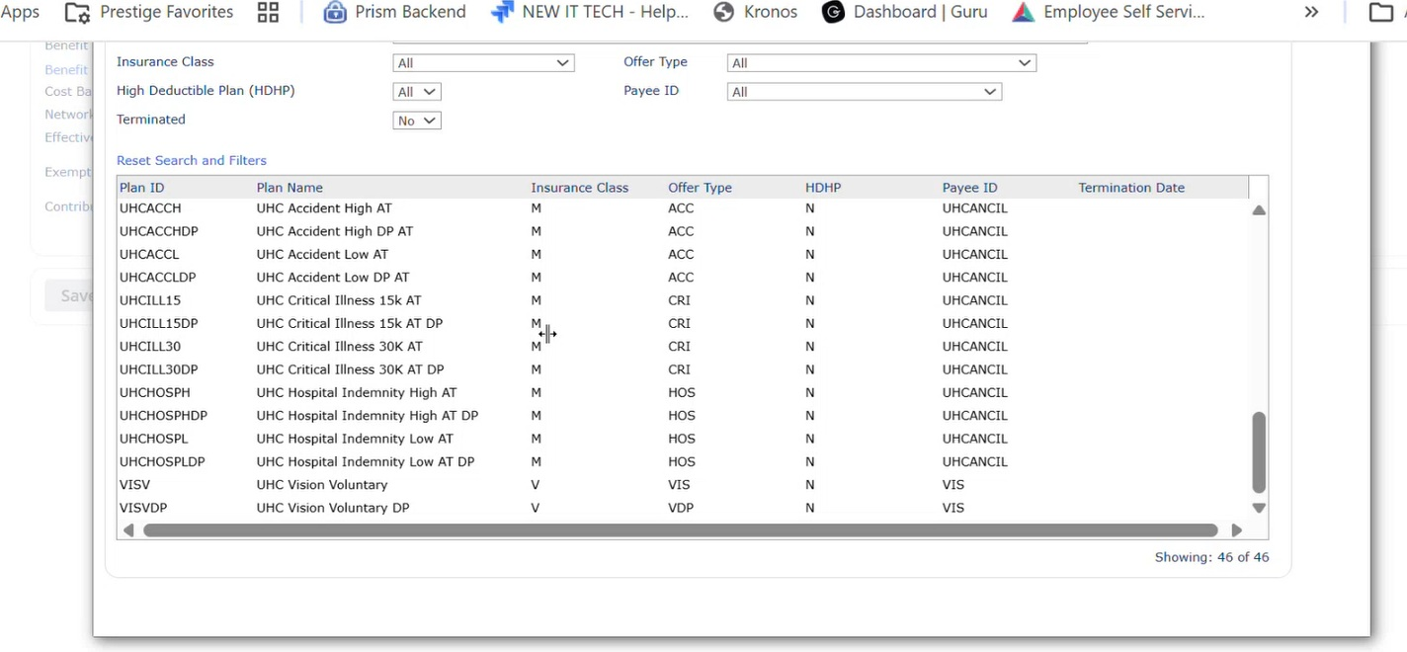
Figure 13 Verify all the benefits plans

Step 13: UnitedHealthcare Vision has one plan. MetLife Davis Vision has two high options and a low option. Keep only the plans that match the client's selection.
Note: Use standard allowance values for UnitedHealthcare Vision. The standard is $130 allowance and 30% discount no changes needed unless directed otherwise.
Remove any leading numbers (e.g., "1.") so the entry reads as: Plan available to: UnitedHealthcare Vision.

Figure 14 Medical Plans & standard allowance

Step 14: Identify the client's dental plan. This client has only one dental plan, MetLife Dental Standard.
Any additional dental plans listed in the default summary should be deleted.
Only the MetLife Dental Standard plan should remain for this client.
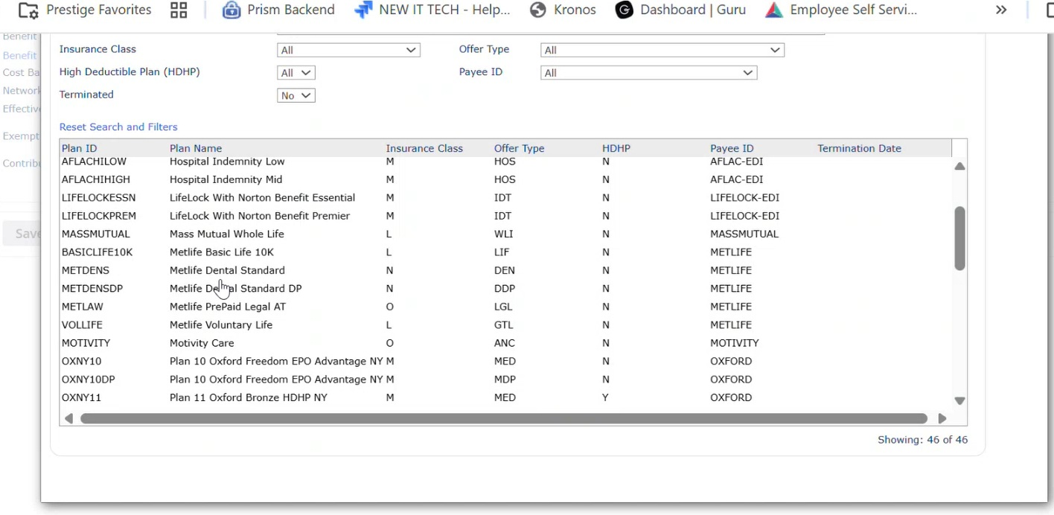
Figure 15 Additional plans can be removed

Review FSA and Life Benefits
Step 15: Navigate to Home tab. Select Benefit Plan Setup.
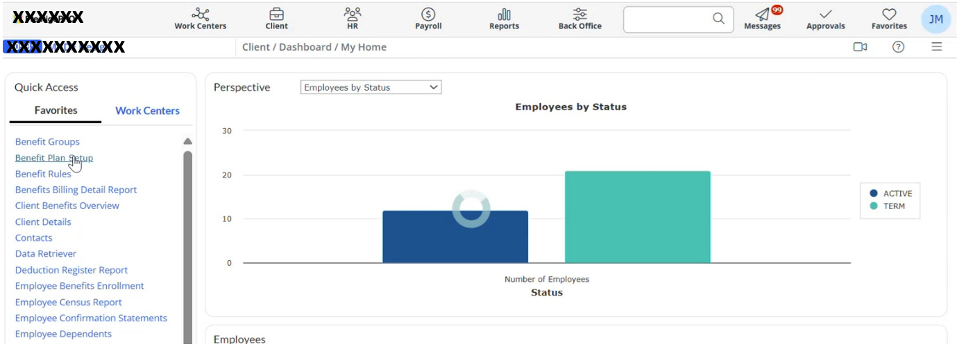
Figure 16 Select Benefit Plan Setup

Step 16: Select Flexible Spending account.
Note: Check for FSA enrollment. If the client has an FSA available, confirm they are enrolled. Clients should receive this benefit unless they have actively chosen not to accept it.
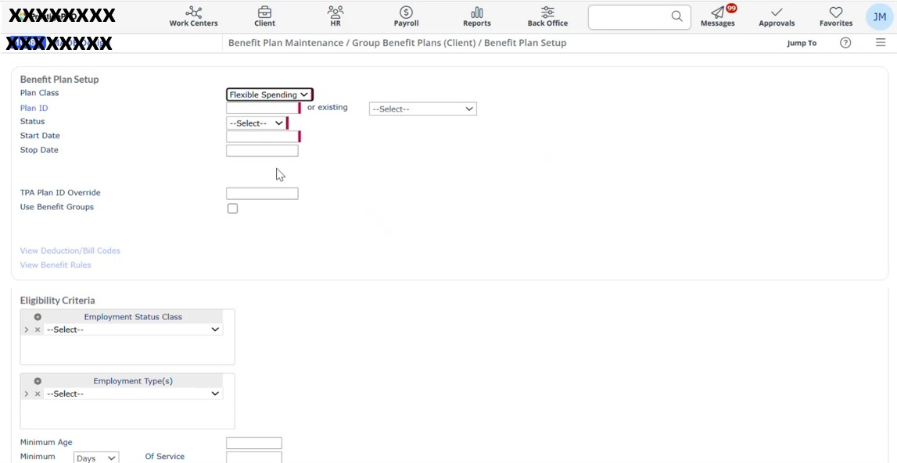
Figure 17 Select Flexible Spending account
Step 17: In Flexible Spending Account, If the plan displays as 125 Prestige 125 Plan, this confirms the client is using your FSA.
If a summary is prepared on November 1st for a January 1st effective date, include both the current year (e.g., 2026) limits and the upcoming year (e.g., 2027) IRS-allowed amounts for Medical FSA and Dependent Care FSA.
The Debit Card Information remains consistent because only one vendor is used for the FSA debit card.
Retain existing debit card details and update only the IRS election limits for Medical FSA, Dependent Care FSA, and the rollover maximum for the new calendar year.
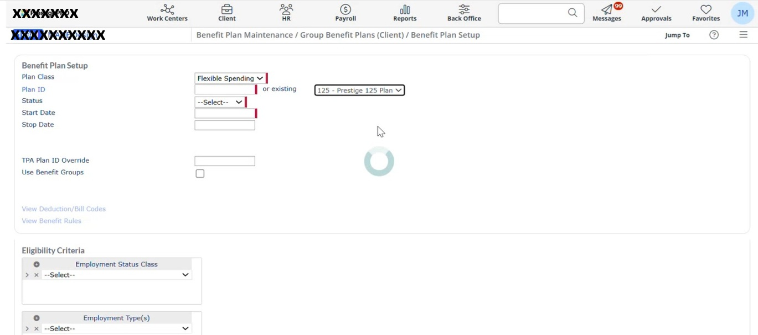
Figure 18 125 Prestige 125 Plan

Note: All Prestige client employers are provided with the MetLife $10,000 company-paid life insurance benefit at no cost to their employees, only if the employer does not already offer a company-paid life insurance benefit.
If a Prestige client employer already offers a company-paid life insurance benefit, such as MetLife $50,000 or 1× annual salary, they are not eligible for the additional Prestige-paid $10,000 life insurance benefit.
Figure 19 MetLife
Step 18: Navigate to the All-Employees class and select Benefit Plan to view all selected benefit plans
Basic Life $10,000: Company-paid benefit provided to all Prestige clients. There is no cost to the employee or the company. Keep this.
Remove: The word "Guardian" and "one times salary plus” these do not apply if the client only has the $10,000 basic life plan.
Keep MetLife: Supplemental Life and Term Life insurance with MetLife should remain.
Keep Mass Mutual: Mass Mutual Whole Life Voluntary is a standard offering for all Prestige clients and should remain.
Keep MetLife Voluntary Life: This is also a standard Prestige voluntary life offering.
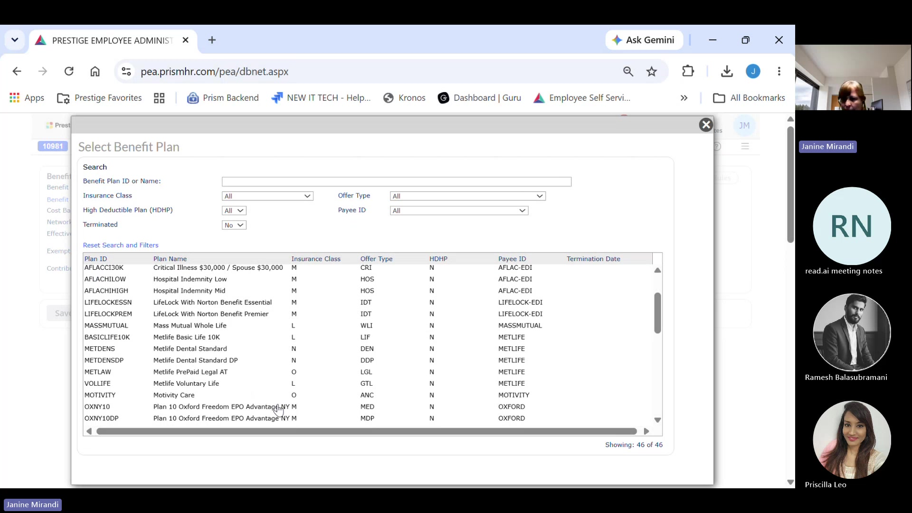
Figure 20 Benefit Plan

Note: All the following are grouped together in one bucket and are offered to Prestige clients:
• Aflac: Accident, Critical Illness, Hospital, and Short-Term Disability
• MetLife: Right Life Lock
• Motivity Care
• Commuter Transit: Through Health Equity
• United Healthcare: Accident, Hospital, and Critical Illness
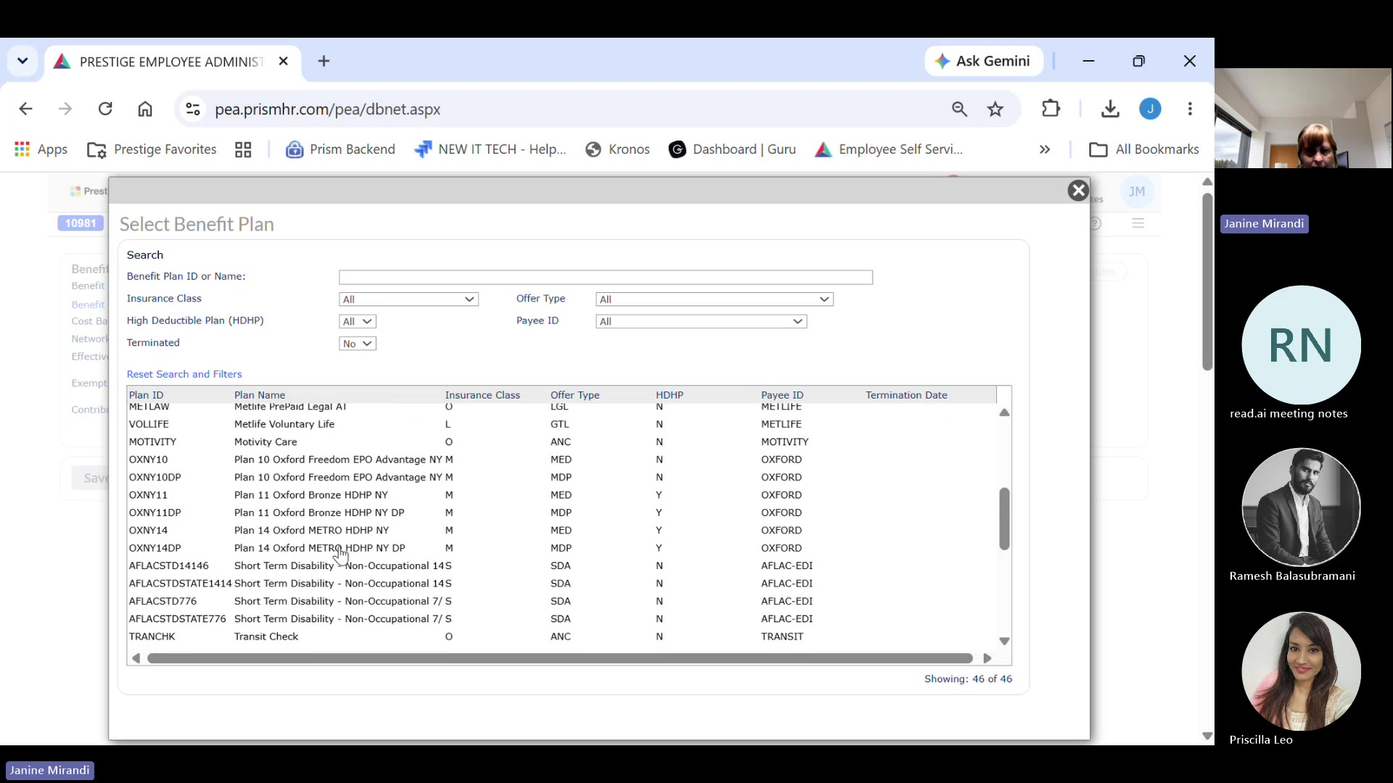
Figure 21 Benefit Plan

Review Additional Benefits
Step 19: Do not fill in any 401k information. Remove the Slavic and American Trust fields from this section.
This discount benefit is offered and should remain listed under the Financial Programs section.
Long-Term Disability: This company does not offer long-term disability (MetLife or Guardian), so the entire Other Benefits section can be removed.
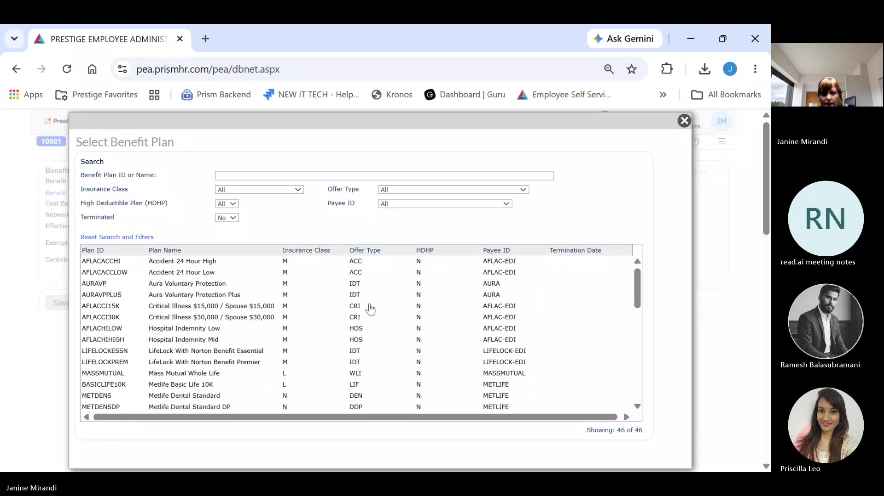
Figure 22 Do not fill in any 401k information

Step 20: Navigate back to the plan setup area to review available plans.
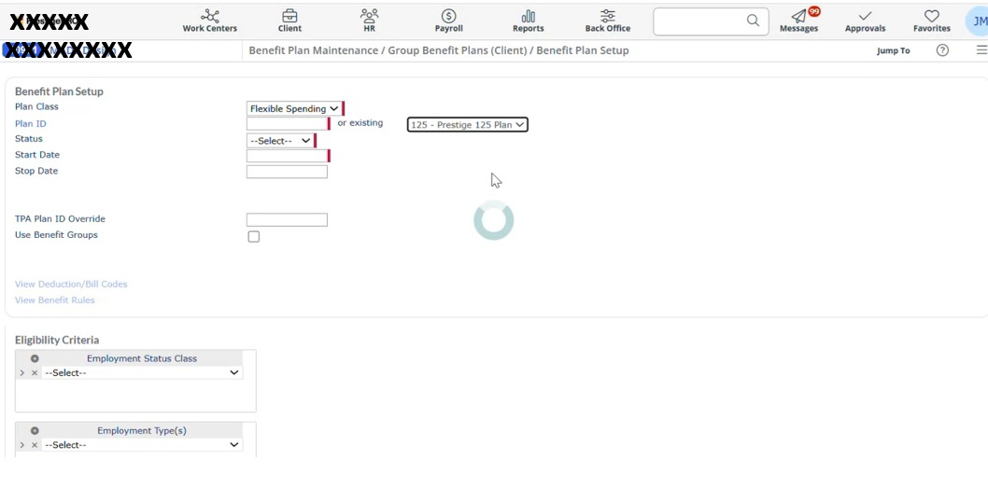
Figure 23 Review available plans
Step 21: Look for HDHP. Any plan that has HDHP noted qualifies for an HSA.
For all HDHP-marked plans, offer the Optum HSA as the associated HSA option.

Format the Benefits Overview
Step 22: Format the Client Name Correctly.
For example, the client's name must appear as MADE Design.
Always place the year before the word "benefits." The title should read: 2026 Benefits Overview.
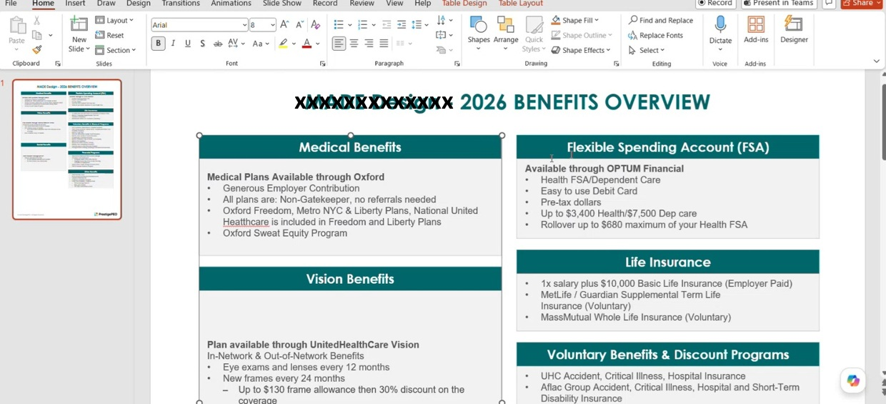
Figure 24 Format the Client Name Correctly

Step 23: Remove the Vision Section. This client has UHC coverage only. The vision section is not applicable and should be deleted entirely.
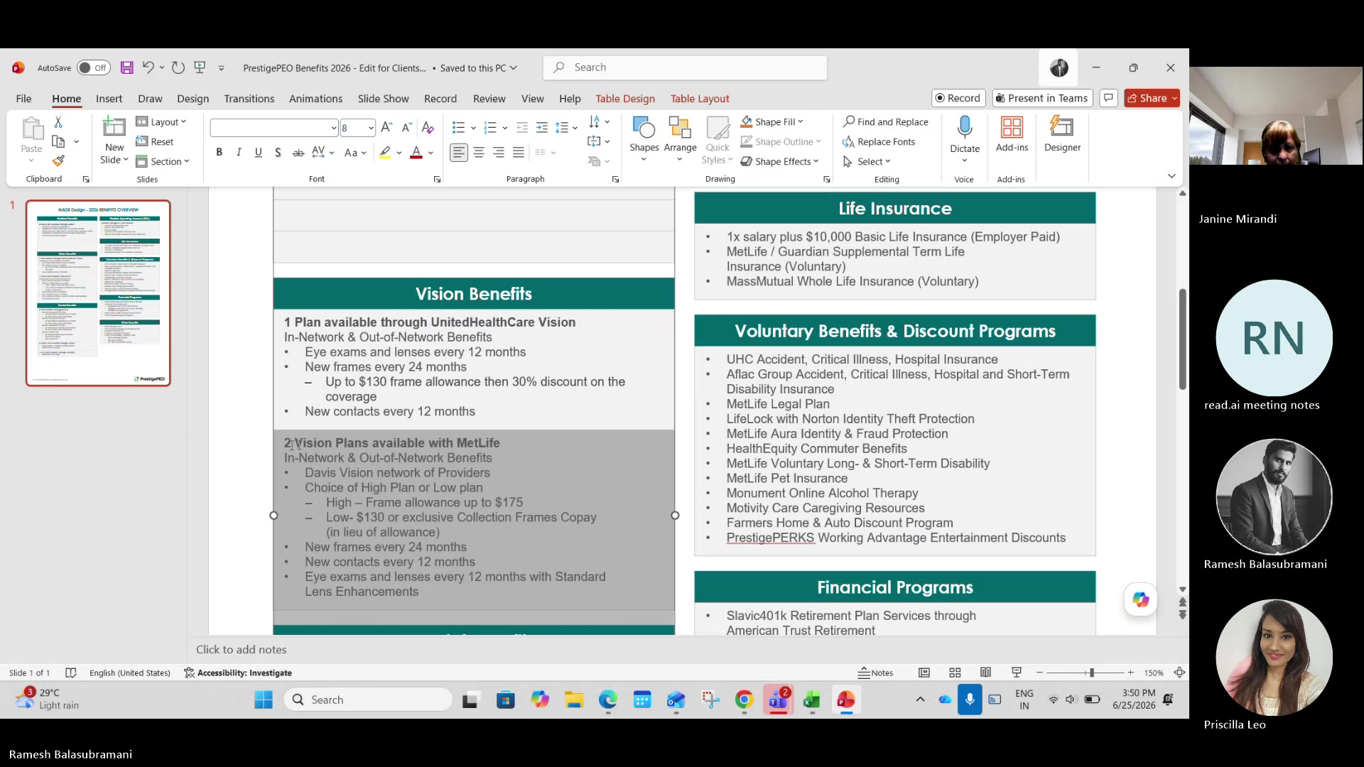
Figure 25 Remove the Vision Section

Step 24: Select the Correct Plan.
This client only offers MetLife Standard PPO. All other plans must be removed from the document.
Section labels such as "Flexible Spending Account" should not be centered within the column the way the vision label was.
Move section labels out do not center across the column.
Note: Confirm Plan Inclusions with the Responsible Person.
Before finalizing, consult with the assigned person for this client to verify which plans to include and confirm which plans from the sample template should be excluded.
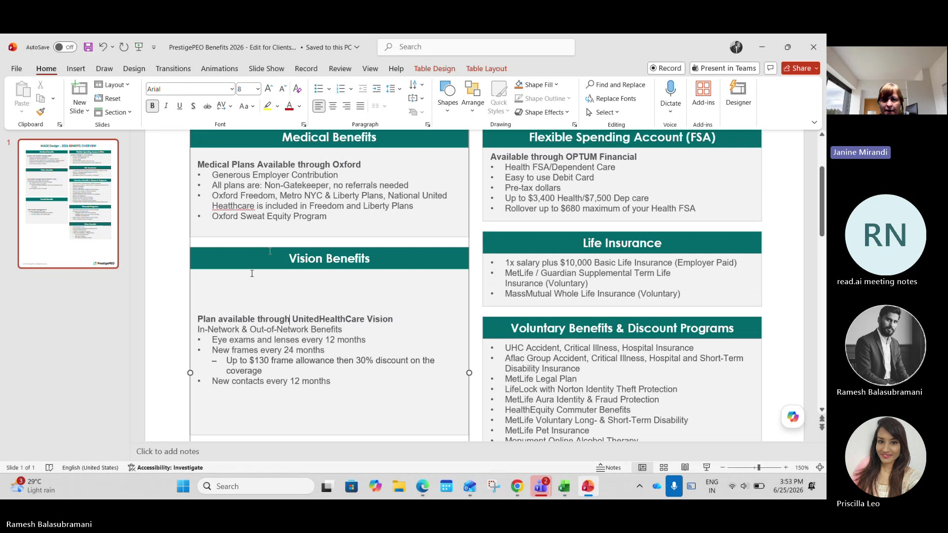
Figure 26 Select the Correct Plan & remove other plans

Perform Final Validation
Step 25: New hires must complete 60 days of employment before coverage eligibility is triggered.
Benefits begin on the first of the month following those 60 days.
This rule is located at the bottom of the benefit rule configuration for the medical plan.

Step 26: Scroll down, in the formatting options panel, add a shape with no color and no border.
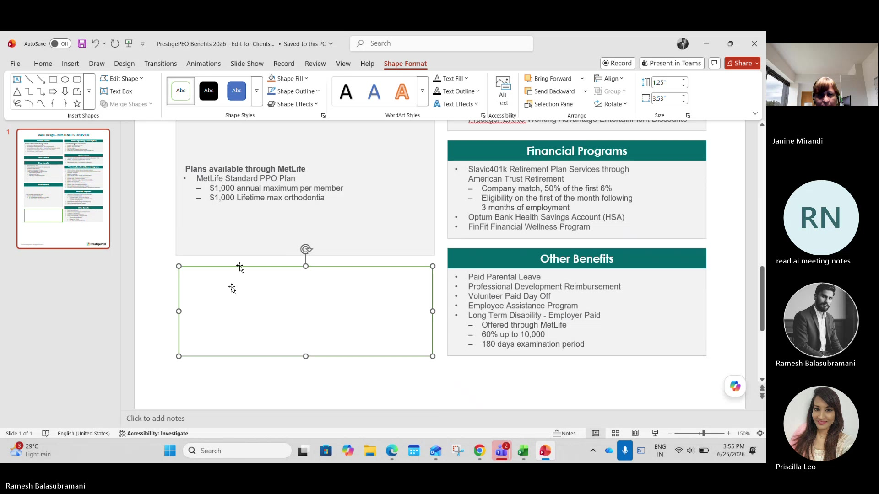
Figure 27 Add shape as Text Box

Step 27: Navigate to the manual text entry field instead of relying on a dropdown or
pre-set selection.
Type the value exactly: Enter "1st of the month following 60 days" to ensure the new hire waiting period is documented correctly.

7. Frequently Asked Questions (FAQs)

- What is the purpose of the Benefits One-Pager?
The Benefits One-Pager provides a concise summary of a client's active benefit offerings and serves as a quick reference guide for employees during onboarding and open enrollment.
- Which source should be used to verify active benefit plans and carriers?
The Client Benefits Overview Report in PRISM should be used as the primary source to identify active benefit plans and carriers. Additional verification may be completed using carrier documentation and benefits guides.
- How do I determine if a benefit plan is active?
A benefit plan is considered active if it does not have an end date in the Client Benefits Overview Report. Plans with an end date should not be included in the Benefits One-Pager.
- How is the employee waiting period determined?
The waiting period is identified from the medical benefit plan rules in PRISM. The waiting period should be documented in the One-Pager using the appropriate eligibility language (e.g., "1st of the month following 60 days").
- What should be done before finalizing the Benefits One-Pager?
Before finalization, verify all benefit plans, carriers, waiting periods, and client-specific selections. Remove any non-applicable plans and confirm plan inclusions with the responsible person or client representative.

8. Appendix:
Figure 1 Power Point Document 5
Figure 2 Go to Client Benefits Overview 6
Figure 3 Client Benefits Overview 7
Figure 4 Plan Details 8
Figure 5 Convert to PDF 9
Figure 6 Client Benefits Overview Report 9
Figure 7 Delete rows that are not applicable 10
Figure 8 Navigate to Benefit Rules 11
Figure 9 Select Benefit Group 11
Figure 10 Select benefit medical plan 12
Figure 11 Minimum Days 13
Figure 12 Select All employees’ class 14
Figure 13 Verify all the benefits plans 15
Figure 14 Medical Plans & standard allowance 16
Figure 15 Additional plans can be removed 17
Figure 16 Select Benefit Plan Setup 18
Figure 17 Select Flexible Spending account 18
Figure 18 125 Prestige 125 Plan 19
Figure 19 MetLife 19
Figure 20 Benefit Plan 20
Figure 21 Benefit Plan 21
Figure 22 Do not fill in any 401k information 22
Figure 23 Review available plans 22
Figure 24 Format the Client Name Correctly 23
Figure 25 Remove the Vision Section 24
Figure 26 Select the Correct Plan & remove other plans 25
Figure 27 Add shape as Text Box 26

9. Process Updates
Process Updates: (If any)
Date | Modification Requested | Modification Executed | Modified Steps | Modifications

